**Create External Read & Write tables using File format(Delta, Parquet, JSON & CSV) & Supporting DML Operations**

**Notebook: Create External Read & Write tables (Delta, Parquet, JSON, CSV) & DML demo**

**1) Mount ADLS Gen2 (optional — choose method you prefer)**

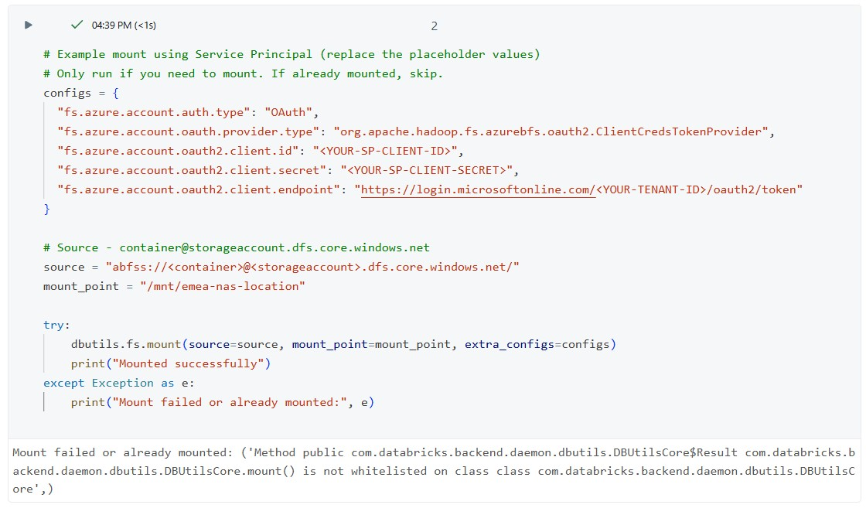

**2) Create PySpark DataFrame from sample CSV(s), clean, and write out in 4 formats**

# Databricks Python cell

from pyspark.sql import SparkSession

from pyspark.sql.types import StructType, StructField, StringType

# Define schema

schema = StructType([

    StructField("employee_id", StringType(), True),

    StructField("employee_name", StringType(), True),

    StructField("Pincode", StringType(), True),

    StructField("Contact_No", StringType(), True),

    StructField("State", StringType(), True),

    StructField("Country", StringType(), True)

])

# Sample data

data = [

    ("1001", "John Smith", "560001", "9876543210", "Karnataka", "India"),

    ("1002", "Priya Sharma", "400001", "9876500001", "Maharashtra", "India"),

    ("1003", "Michael Johnson", "94102", "9876500002", "California", "USA"),

    ("1004", "Emma Brown", "2000", "9876500003", "NSW", "Australia"),

    ("1005", "David Wilson", "10115", "9876500004", "Berlin", "Germany")

]

# Create DataFrame

df = spark.createDataFrame(data, schema)

# Path where Step 2 will read the CSV

output_path = "/mnt/emea-nas-location/sas-location/raw/employee_dir/"

# Write CSV file (overwrite if exists)

df.write.mode("overwrite").option("header", "true").csv(output_path)

print(f"Sample CSV created at {output_path}")

display(dbutils.fs.ls(output_path))

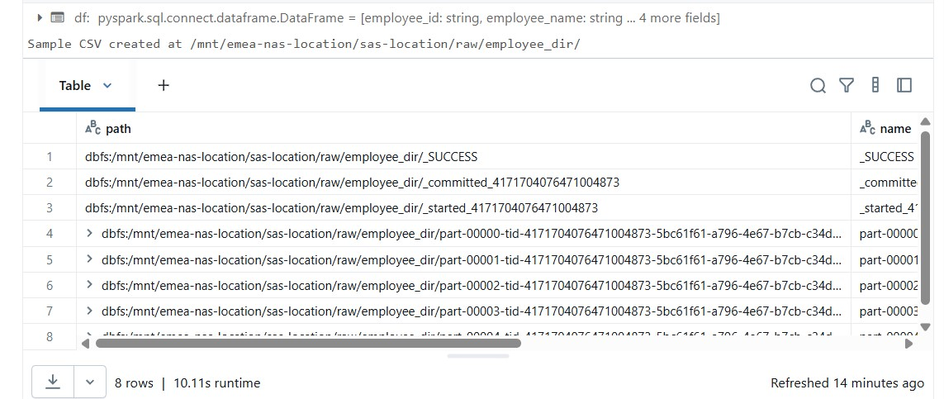

# Python / PySpark cell

from pyspark.sql.types import StructType, StructField, StringType

from pyspark.sql.functions import trim, regexp_replace, col, lit

schema = StructType([

StructField('employee_id', StringType(), True),

StructField('employee_name', StringType(), True),

StructField('Pincode', StringType(), True),

StructField('Contact_No', StringType(), True),

StructField('State', StringType(), True),

StructField('Country', StringType(), True),

])

# Adjust the input path to the folder containing input CSV(s)

input_path = "/mnt/emea-nas-location/sas-location/raw/employee_dir/*.csv"

df = spark.read.format('csv') \

.option("header", "true") \

.schema(schema) \

.load(input_path)

# Clean data: trim & remove quotes

clean_df = df.select([trim(regexp_replace(col(c), r'[\"\\\']', "")).alias(c) for c in df.columns])

display(clean_df.limit(10))

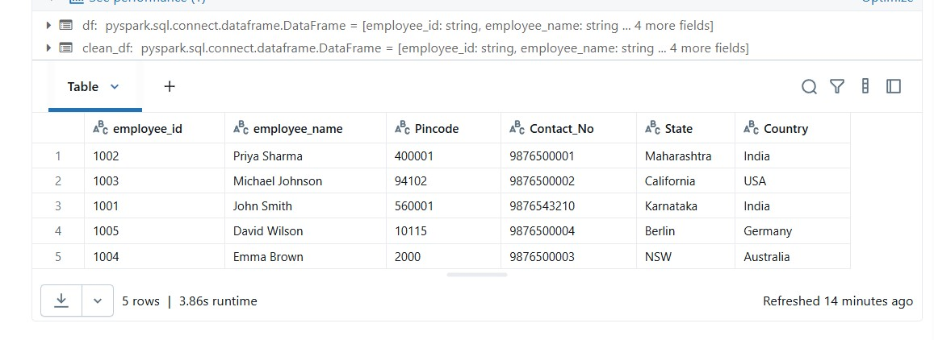

# Write out to Parquet, Delta, CSV, JSON (partitioned by Country)

base_out = "/mnt/emea-nas-location/sas-location/raw/employee_{}"

# Parquet

clean_df.write.format("parquet").partitionBy("Country").mode("overwrite")\

.save(base_out.format("parquet"))

# Delta

clean_df.write.format("delta").partitionBy("Country").mode("overwrite")\

.save(base_out.format("delta"))

# CSV (note: when writing partitioned CSV, subfolders created)

clean_df.write.format("csv").option("header","true").partitionBy("Country").mode("overwrite")\

.save(base_out.format("csv"))

# JSON

clean_df.write.format("json").partitionBy("Country").mode("overwrite")\

.save(base_out.format("json"))

print("Writes complete. Check the folders under:", base_out.format("*"))

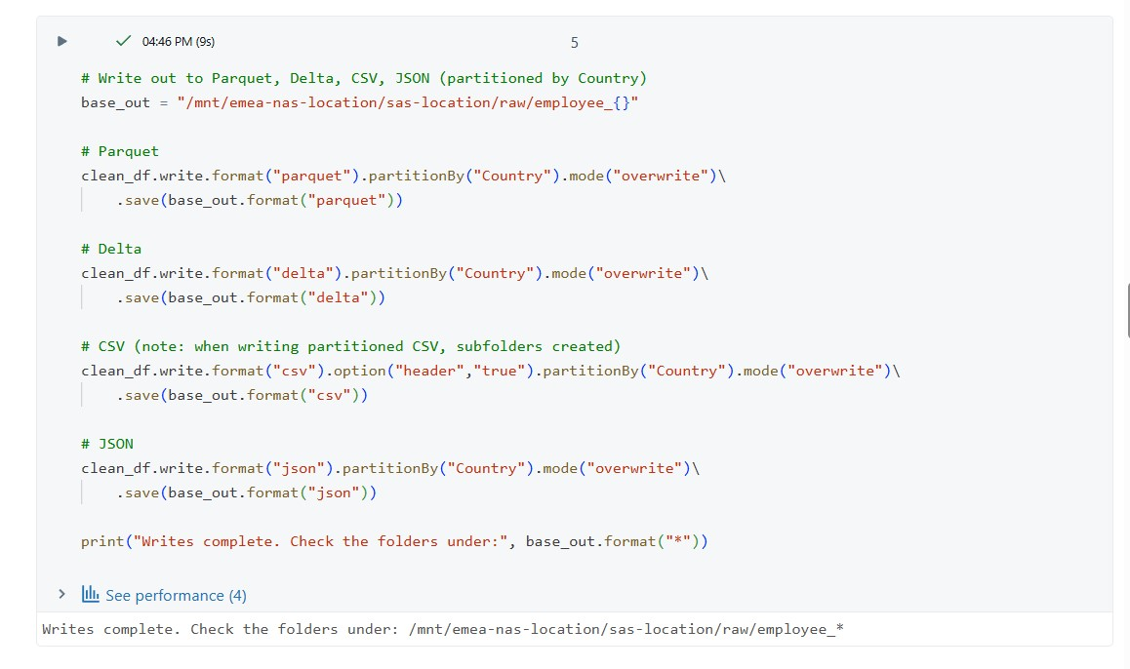

**3) Use Hive Metastore (or Unity Catalog) — choose the right catalog/schema**

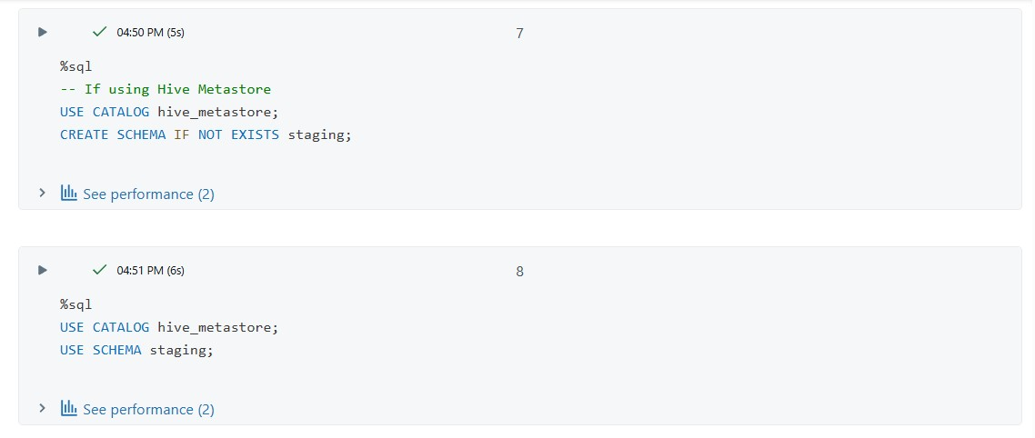

**4) CREATE EXTERNAL TABLE (Delta) — using data source (recommended for Delta)**

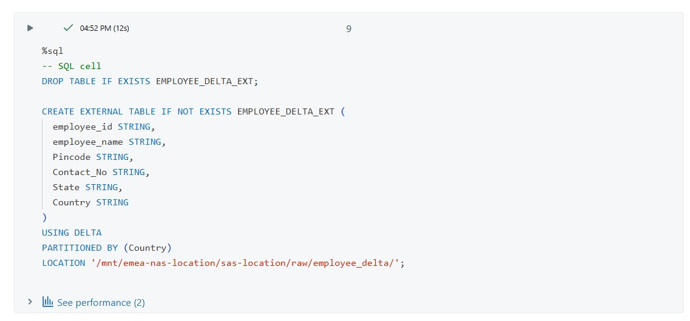

**5) CREATE EXTERNAL TABLE (Parquet) — USING data source**

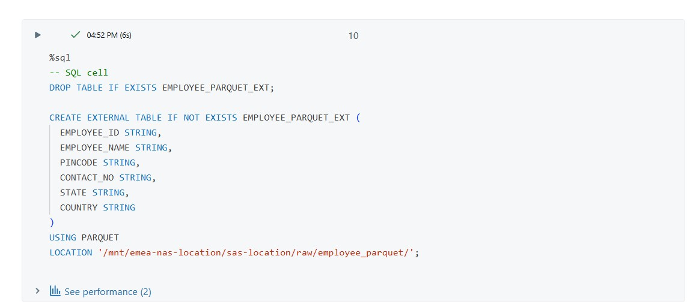

**6) CREATE EXTERNAL TABLE (CSV)**

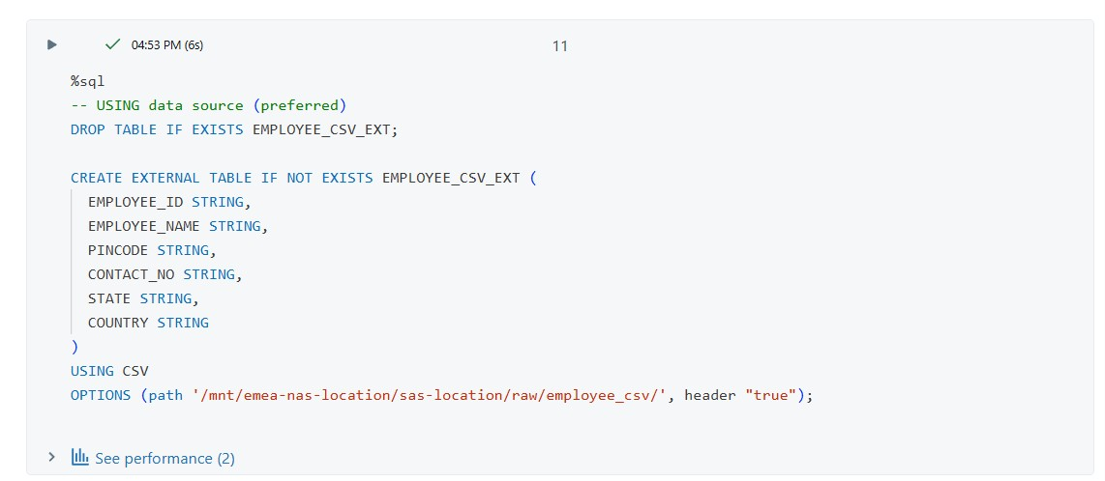

**7) CREATE EXTERNAL TABLE (JSON)**

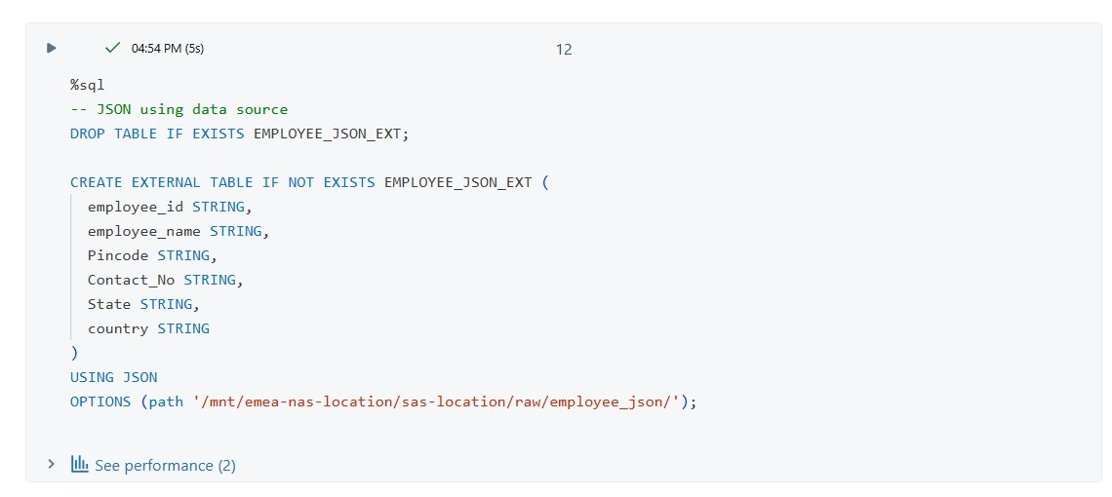

**8) Verify reads (quick SELECT checks)**

-- Try selects

SELECT count(*) FROM EMPLOYEE_DELTA_EXT;

SELECT * FROM EMPLOYEE_PARQUET_EXT LIMIT 10;

SELECT * FROM EMPLOYEE_CSV_EXT LIMIT 10;

SELECT * FROM EMPLOYEE_JSON_EXT LIMIT 10;

